**Student’s Name…………………………………………… stream……………….**

**School…………………………………………………….. Class………………….**

**(write your name, class stream in the spaces provided.)**

**553/1**

**BIOLOGY**

**(Theory)**

**Paper 1**

**2hours**

**LOWER SECONDARY CERTIFICATE**

MASULIITA SECONDARY SCHOOL

**S.3 END OF TERM ONE FORMATIVE ASSESSMENT**

**EXAMINATIONS**

**BIOLOGY**

**(THEORY)**

**paper 1**

**2hours**

Instructions:

* Answer all questions in the spaces provided.
* Illustrations in form of drawings should be made where necessary, with a sharp pencil.

***For official use only***

|  |  |  |
| --- | --- | --- |
| ***Number*** | ***Score*** | ***Teacher’s comment*** |
| 1 |  |  |
| 2 |  |  |
| 3 |  |  |
| 5 |  |  |
| 5 |  |  |

1. The diagram shows a cross-section through a leaf when viewed using a light microscope.

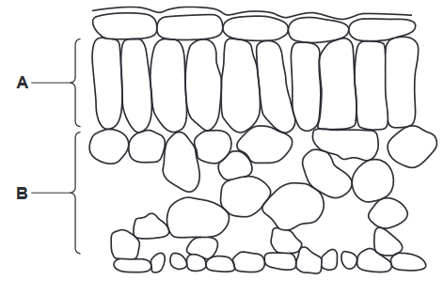  
(a) (i) State the term used to describe a group of cells, such as those in part A or part B of the leaf cross-section. (1mk)  
..........................................................................................................................................  
(ii) The diagram shows an enlargement of one cell from part A of the leaf cross-section.

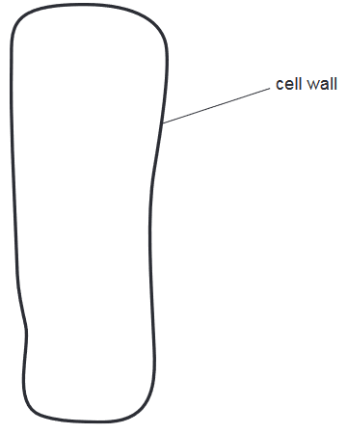  
Complete the diagram of the cell by drawing and labelling to show the position of  
• chloroplasts(1mk)  
• three other types of named cell components that will be visible.(3mks)  
  
(b) The cell wall of a plant cell can be removed by treating the cell with a digestive enzyme.  
(i) Name the enzyme and the substrate for this enzyme.  
Enzyme ............................................. (1mk)

Substrate………………………………………………….(1mk)

(b) with reference the the crosssection of the leaf above, describe how a leaf is adapted to photonthesis (3mks)  
...........................................................................................................................................  
...........................................................................................................................................  
...........................................................................................................................................  
...........................................................................................................................................  
...........................................................................................................................................  
...........................................................................................................................................  
...........................................................................................................................................  
[Total: 10]

1. The photograph shows a fruit of the tomato plant. 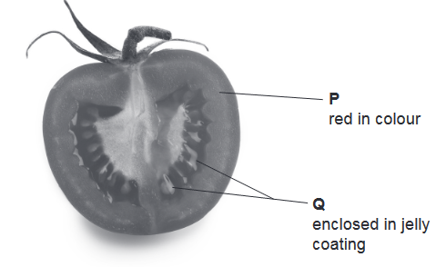

The fruit has been cut in half to show the structures labelled P and Q.  
P red in colour and Q enclosed in jelly coating

(a)Name parts labelled P and Q (2mks)

P………………………………………………

Q………………………………………………  
(b) Before fertilisation, structures P and Q in the fruit were structures in a flower of the tomato plant.  
Complete the table to name the structures in a flower that have developed into structures P and Q.

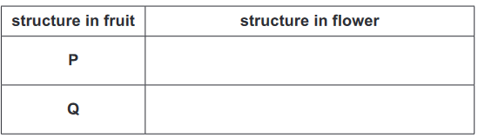  
  
(c) Suggest, with reference to the photograph, adaptations of the tomato to dispersal by animals. (3mks)  
...........................................................................................................................................  
...........................................................................................................................................  
...........................................................................................................................................  
...........................................................................................................................................   
...........................................................................................................................................  
...........................................................................................................................................  
...........................................................................................................................................  
...........................................................................................................................................

(c)What are the similarities between the tomato fruit and structure labelled Q (2mks)

………………………………………………………………………………………………………………………………………………………………………………………………………………………………………………………………………………………………………………………

[Total 8mks]

1. Malnutrition is a global problem.

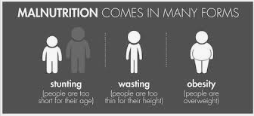

In early 2020 the world population was approximately 7.8 billion people. Of these it is estimated that 1.9 billion adults were overweight and 462 million underweight.

1. Explain what is meant by a balanced diet and outline its components. (3mks)  
   .............................................................................................................................................  
   .............................................................................................................................................  
   .............................................................................................................................................  
   .............................................................................................................................................  
   .............................................................................................................................................  
   .............................................................................................................................................  
   .............................................................................................................................................  
   (b) Discuss the effects on health of being underweight and of being overweight.(4mks)  
   **Underweight**  
   .............................................................................................................................................  
   .............................................................................................................................................  
   .............................................................................................................................................  
   ............................................................................................................................................  
   .............................................................................................................................................  
   **Overweight**

..........................................................................................................................................  
.............................................................................................................................................  
.......................................................................................................................................................................................................................................................................................................................................................................................................................................

(c) If you were the Minister of Health, how would you address the challenge of undernutrition in your country? (3mks)

………………………………………………………………………………………………………………………………………………………………………………………………………………………………………………………………………………………………………………………………………………………………………………………………………………………………………………………………………………………………………………………………………

[Total 10mks]

1. The diagram shows the teeth in the lower jaw of a human.  
   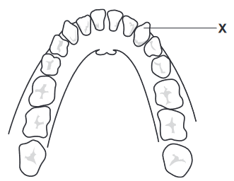  
   (a) Name the type of tooth labelled X and describe one function of this type of tooth.(2mks)  
   type of tooth ................................................  
   function ................................................................................................................................  
   .................................................................................................................................

(b) Food can be sweetened using honey or sugar.  
The graph shows how the pH of saliva in the mouth changes with time after eating food sweetened with honey or sugar.  
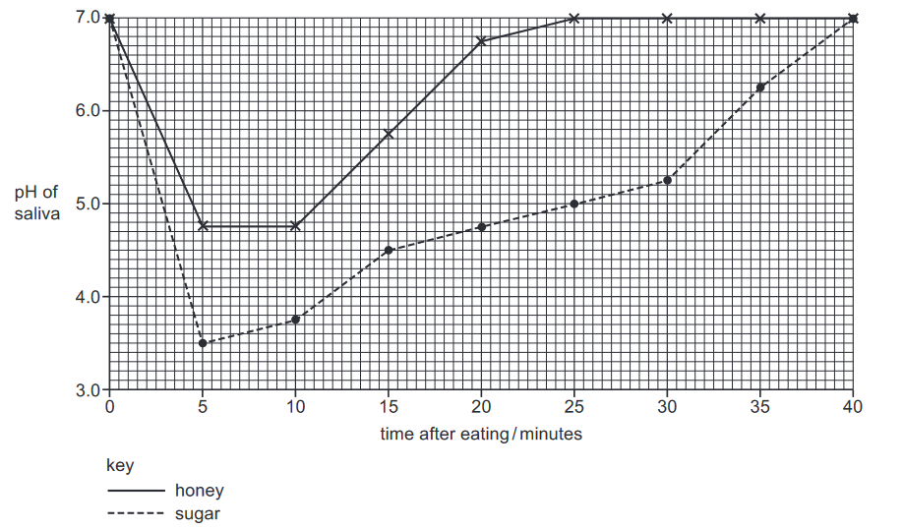  
(i) State the lowest pH of saliva in the mouth after eating food sweetened with honey.(1mk)  
...........................................................................................................................

(ii) It takes more time for saliva to return to pH 7.0 after eating food sweetened with sugar than after eating food sweetened with honey.  
State how much more time it takes for the pH to return to 7.0. (2mks)  
............................................................................................................................   
  
(ii) How would you advise your friends on how to best care for their teeth (4mks)  
.................................................................................................................................  
.....................................................................................................................................................................................................................................................................................................................................................................................................................................................................................................................................................................................................................................................................

[total 09mks]

1. The photograph shows a mammalian organ.  
   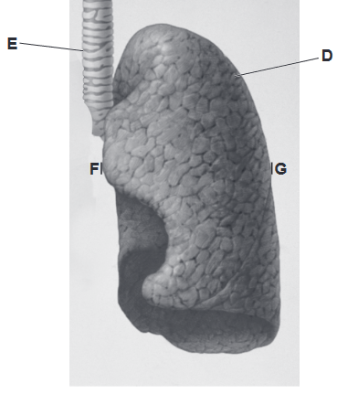  
   (a) (i) Identify the organ labelled D (1mks)

......................................................................................   
(ii) Identify the structure labelled E. (1mks) ..................................................................................   
(b) In the space below, make a large drawing of structures D and E as they appear in the photograph. Do not include the surface detail of structure D in your drawing.(3mks)  
(c) (i) On the photograph, draw a line between F and G. Measure and record this length. (2mks)  
.................................................... mm   
(ii) On your drawing, draw a line at the same location as the line F–G.  
Measure and record the length of this line. (2mks)

................................................... mm   
(iii) Use your measurements in (c)(i) and (c)(ii) to calculate the magnification of your drawing  
compared to the photograph. Give your answer to one decimal place.  
show your working. (2mks)

magnification X.......  
(d) The photomicrographs show the detail of the same organ from a smoker and a non-smoker.  
Both photomicrographs are to the same scale. 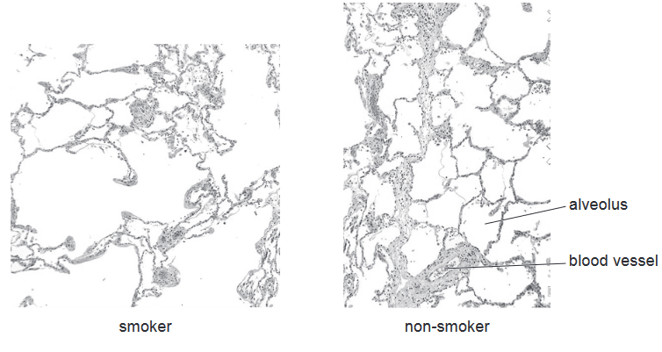  
Complete the table to identify two differences between the two photomicrographs.(2mks)  
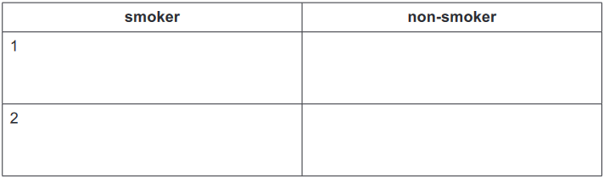  
  
[Total 13mks]